Working with Local Area Networks and Access Networks.

**1.Learning objectives:**

* **Get acquaintance with LAN**
  + Create a Lan using a Switch
  + Understand the working of a switch
  + Differentiate a hub and a switch
* Access Network
  + Connecting different networks with routers
  + Sense the protocol and learn the meaning of PDU
  + **Accessing the internet**

**2.Topology**

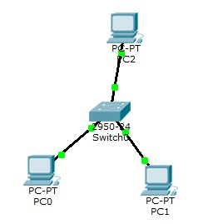

**3.Conduction**

**Part A: Select ‘Real mode’**

|  |  |  |  |
| --- | --- | --- | --- |
|  | **Do** | **What to observe** | Write down / Answer the question |
| 1 | Set up the network as shown in the diagram using a HUB | Observe red dot turning to green. | **Ping before it turns to green and after it turns to green. What is the difference?**  **Ans :** |
| 2 | Configure IP addresses  PC0 : 192.168.1.1  PC1 : 192.168.1.2  PC2 : 192.168.1.3 |  | **How many interfaces are available in PC0?**  **Ans :**  **How many interfaces are there in switch ?**  **Ans :** |
| 3 | Ping from PC0 to PC1  Ping from PC0 to PC2 | Result : Success or Failure ? | **Ans :** |

**Part** B**: Select ‘Simulation mode’**

|  |  |  |  |
| --- | --- | --- | --- |
|  | **Do** | **What to observe** | Write down / Answer the question |
| 1 | Ping from PC0 to PC1 | Movement of the packet | **What is the observation ? Do packets go from all ports?**  **Ans :** |
| 2 |  | Event list | **How many events have occurred?**  **Ans :**  **Name the protocols.**  **Ans :** |

**Reset the configuration and repeat the experiment.**

4. Write the differences between Hub and a switch.

**5**. **Set up an Access Network and inspect a PDU**

**5.1. Configuration**

|  |  |  |  |  |  |
| --- | --- | --- | --- | --- | --- |
| **Sl. No.** | **Equipment Title** | **Label** | **IP Address** | **Subnet Mask** | **Gateway IP address** |
| 1 | Desktop Computer | PC0 | 192.168.1.2 | 255.255.255.0 | 192.168.1.1 |
| PC1 | 192.168.1.3 | 255.255.255.0 | 192.168.1.1 |
| PC2 | 192.168.1.4 | 255.255.255.0 | 192.168.1.1 |
| PC3 | 192.168.1.5 | 255.255.255.0 | 192.168.1.1 |
| 2. | Switch | 1 |  |  |  |
| 3 | Router with 2 interfaces | Fa0/0 | 192.168.1.1 | 255.255.255.0 |  |
| Fa1/0 | 192.168.2.1 | 255.255.255.0 |  |
| 4 | Server | 1 | 192.168.2.2 | 255.255.255.0 | 192.168.2.1 |

***To set the Gateway address, select ‘Settings’ and enter the IP address in the ‘Gate way’ box.***

**Topology:**

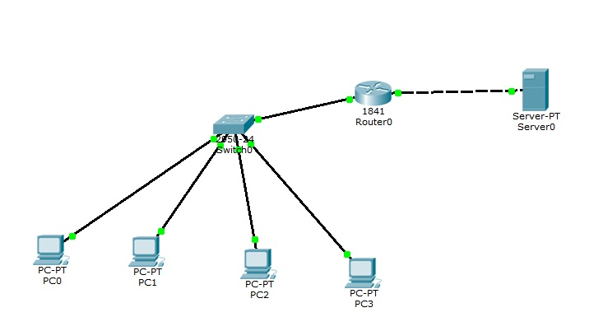

**5.2. Test the network**

**5.2.1. Real time mode**

|  |  |  |  |
| --- | --- | --- | --- |
|  | **Do** | **observe** | Write down / Answer the question |
| 1 | **Select Real time mode** |  |  |
| 2 | Ping from any client to any other client  Ping from any client to the server |  | **Status of the ping**  **Ans :**  **Ans :** |
| 3 | Click one of the client PCs  Click “Desk Top”  Click “Web Browser”  Enter at url : 192.168.2.2 |  | **Write down the first two lines displayed**  **Ans :** |
| 4 | Ping from client to server | Result : Success or Failure ? | **Ans :** |

**5.2.2. Simulation mode**

**Repeat the steps done in 5.2.1**

Write down the contents of HTTP PDU,

a) When the packet enters the server

b) When the packet leaves the server

**6. Change the IP address of the Server to 1.1.1.7 ( Subnet mask 255.0.0.0) and test the network.**

**Write down your observations.**

**Post Lab Assignment:**

**7. Try adding one more server to the router ; Configure the IP address of your choice and test .**

**Write down your observations.**